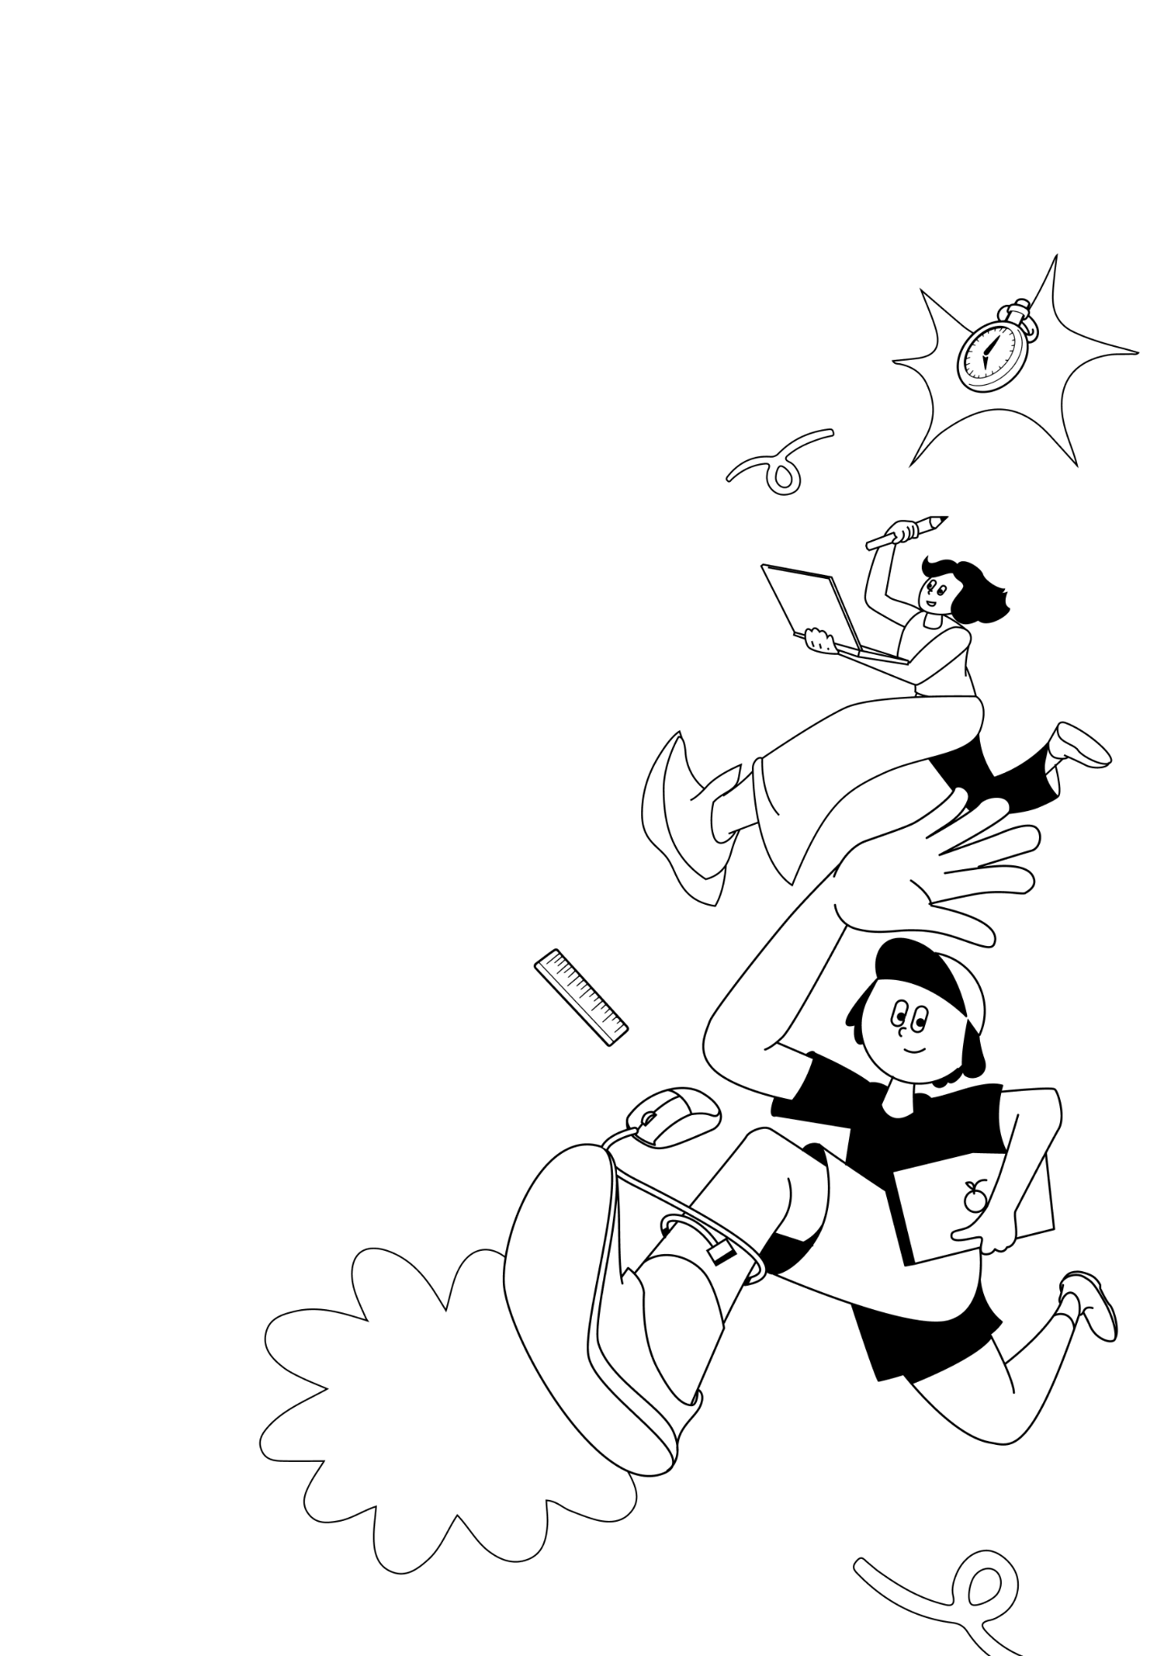
LKSN 2024

TEKNOLOGI
DESAIN GRAFIS

Module 1 (EN)
Design Process

LKS Nasional
AGUSTUS 2024

INSTRUCTIONS FOR COMPETITOR

- Create a folder named Competitor Number_Your Name
  - The folder must contain all final files in the format specified in the technical specification.
- You must use all the text provided in the appendix for each tasks as specified, adding or subtracting text from the appendix is ​​not allowed.
- You may use the image/photo assets that have been provided.
- You may use create raster element or additional vector provided.
- You are not permitted to use images/photos from internet or from sources other than provided.

Example of arranging folders on a Competitor’s computer:
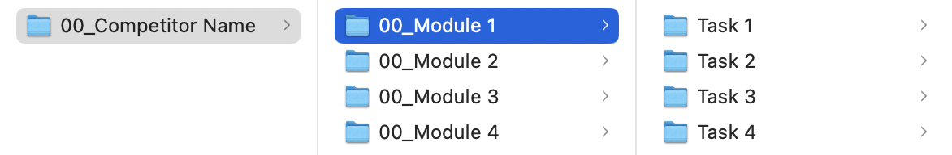

MODULE FOLDER
Module 1

PROJECT DESCRIPTION AND TASKS
This module consists of 4 (FOUR) tasks that you have to do, you are not allowed to do outside the time limit that has been given.

TASK 1: MINDMAP

OBJECTIVE
Create a Mindmap from Module X Topic using the 5W 1H information gathering method. After that, decide 3 (THREE) keywords to create a Moodboard.

REQUIREMENT
- Using 5W 1H information gathering method.
- Decide 3 keywords.

TECHNICAL SPECIFICATION
Dimension : A4 - 297 x 210 mm (Landscape)
Image Resolution : 150 ppi
Color Mode : RGB
Design element : 5W 1H

Working File Format : AI/PSD
Final File Format : JPG

Folder Name : Competitor Number_Module 1
Sub Folder Name : Task 1
File Name : Competitor Number_Module 1_Mindmap

YOU MUST DELIVER
Folder & file names as specified in "INSTRUCTIONS FOR COMPETITOR".
Only links & files from this folder will be marked.

1 x JPG (Final File)

TASK 2: MOODBOARD

OBJECTIVE
Create a Moodboard using 3 keywords from the mindmap that you created in Task 1.

REQUIREMENT
Must include:
- Color Scheme Selection.
- Typography Selection.
- Image & Shape Selecit.on.

TECHNICAL SPECIFICATION
Dimension : A4 - 297 x 210 mm (Landscape)
Image Resolution : 150 ppi
Color Mode : RGB
Design Element : Color, Typography, Image, Shape

Working File Format : AI/PSD
Final File Format : JPG
Image Format : PNG, JPG, PSD, AI, EPS, SVG

Folder Name : Competitor Number_Module 1
Nama Sub Folder : Task 2
Nama File : Competitor Number_Module 1_Moodboard

YOU MUST DELIVER
Folder & file names as specified in "INSTRUCTIONS FOR COMPETITOR".
Only links & files from this folder will be marked.

1 x AI or 1 x PSD (Working File)
1 x JPG (Final File)

TASK 3: VECTOR LOGO

OBJECTIVE
Create 1 (ONE) vector logo based on the mindmap and moodboard that you have created.

REQUIREMENT
- The logo must combination of Logogram & Logotype.
- Maximum 3 (THREE) colors, which MUST including one color HEX - #E7411B.

TECHNICAL SPECIFICATION
Dimension : A4 - 297 x 210 mm (Landscape)
Image Resolution : 150 ppi
Color Mode : RGB
Design Element : Logogram & Logotype
Text : Module 1 Appendix 1.pdf

Working File Format : AI
Final File Format : JPG

Folder Name : Competitor Number_Module 1
Sub Folder Name : Task 3
File Name : Competitor Number_Module 1_Logos

YOU MUST DELIVER
Folder & file names as specified in "INSTRUCTIONS FOR COMPETITOR".
Only links & files from this folder will be marked.

1 x AI - Text Outlined (Working File)
1 x JPG (Final File)

TASK 4: STYLESCAPES

OBJECTIVE
Create stylescape based on the logo that you have created with including Typography, Color Scheme, Image & Shape elements.

REQUIREMENT
- Must including Typography, Color Scheme, Image & Shape.
- Use minimum 4 (FOUR) images.
- Logo from Task 3.

TECHNICAL SPECIFICATION
Dimension : 3240 x 1080 px (Landscape)
Image Resolution : 150 ppi
Color Mode : RGB
Text : Module 1 Appendix 1.pdf

Working File Format : AI or PSD
Final File Format : JPG
Image Format : PNG, JPG, PSD, AI, EPS, SVG

Folder Name : Competitor Number_Module 1
Sub Folder Name : Task 4
File Name : Competitor Number_Module 1_Stylescapes

YOU MUST DELIVER
Folder & file names as specified in "INSTRUCTIONS FOR COMPETITOR".
Only links & files from this folder will be marked.

1 x AI or 1 x PSD (Working File)
1 x JPG (Final File)

